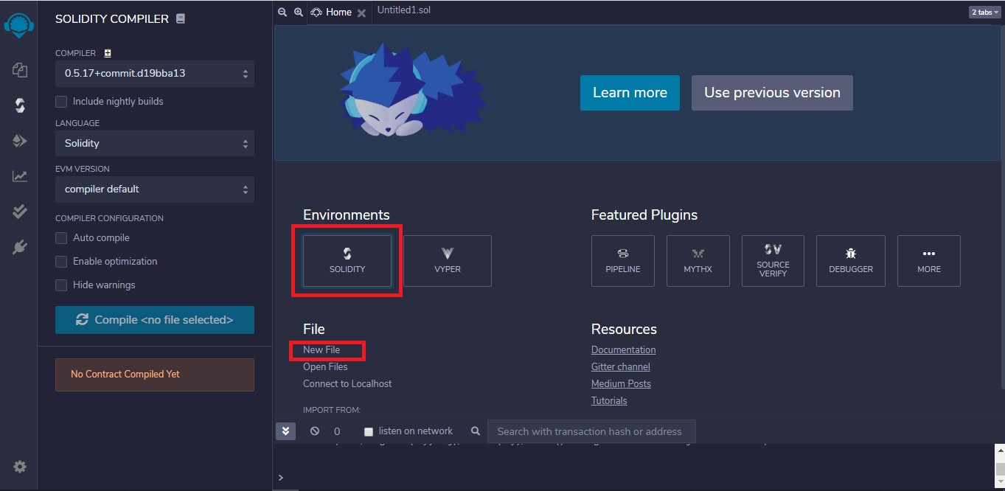
Assignment No. 3

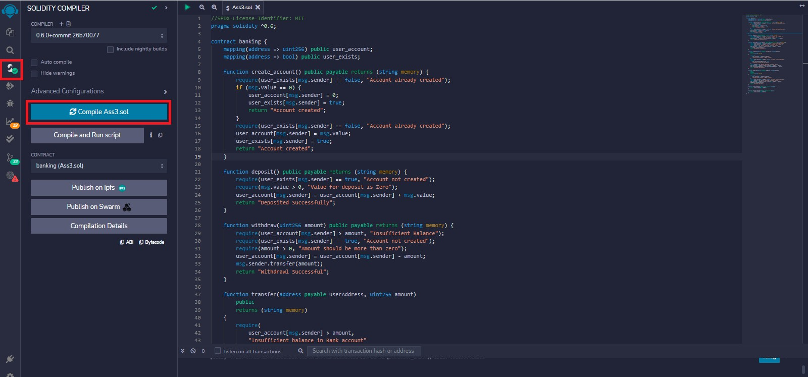

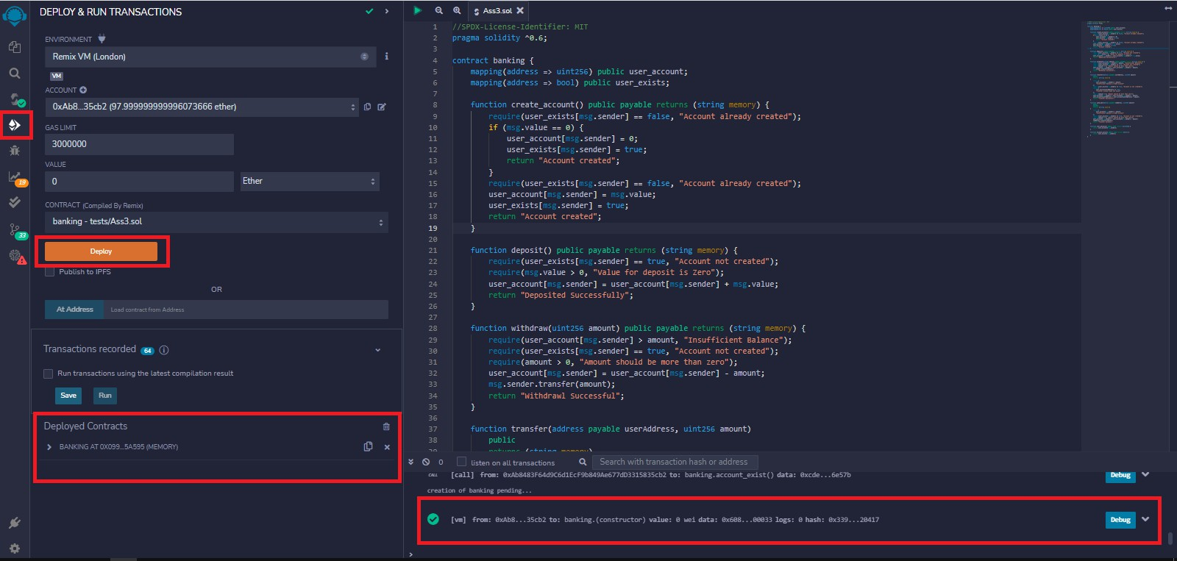

Code:

//SPDX-License-Identifier: MIT pragma so solidity ^0.6;
contract banking
{
mapping(address=>uint) public user_account; mapping(address=>bool) public user_exists;

function create_account() public payable returns(string memory)
{
require(user_exists[msg.sender]==false,'Account already created'); if(msg.value==0)
{
user_account[msg.sender]=0; user_exists[msg.sender]=true;
return "Account created";
}
require(user_exists[msg.sender]==false,"Account already created"); user_account[msg.sender]=msg.value;
user_exists[msg.sender]=true; return "Account created";
}

function deposit() public payable returns(string memory)
{
require(user_exists[msg.sender]==true,"Account not created"); require(msg.value>0,"Value for deposit is Zero");
user_account[msg.sender]=user_account[msg.sender]+msg.value; return "Deposited Successfully";
}

function withdraw(uint amount) public payable returns(string memory)
{
require(user_account[msg.sender]>amount,"Insufficient Balance"); require(user_exists[msg.sender]==true,"Account not created"); require(amount>0,"Amount should be more than zero");
user_account[msg.sender]=user_account[msg.sender]-amount; msg.sender.transfer(amount);
return "Withdrawl Successful";
}

function transfer(address payable userAddress, uint amount) public returns(string memory)
{
require(user_account[msg.sender]>amount,"Insufficient balance in Bank account"); require(user_exists[msg.sender]==true,"Account is not created"); require(user_exists[userAddress]==true,"Transfer account does not exist"); require(amount>0,"Amount should be more than zero");
user_account[msg.sender]=user_account[msg.sender]-amount; user_account[userAddress]=user_account[userAddress]+amount;
return "Transfer Successful";
}

function send_amt(address payable toAddress, uint256 amount) public payable returns(string memory)
{
require(user_account[msg.sender]>amount,"Insufficeint balance in Bank account"); require(user_exists[msg.sender]==true,"Account is not created"); require(amount>0,"Amount should be more than zero");
user_account[msg.sender]=user_account[msg.sender]-amount; toAddress.transfer(amount);
return "Transfer Success";
}

function user_balance() public view returns(uint)

{
return user_account[msg.sender];
}

function account_exist() public view returns(bool)
{
return user_exists[msg.sender];
}
}

